**The Gadget Zone - Ecommerce Websites for Electronic Gadgets**

**Project Summary:** The project will be focused on creating an ecommerce website hosting electronic gadgets with the facility to browse through the products and making purchases. It will have multiple screens like home page, product description page, cart details, etc. The website will facilitate saving the cart items for someone who wants to continue later. It will also allow saving customer information for new and existing customers. The product description page will also show similar products on the basis of attributes and also products bought by other customers who had bought the displayed item. The dataset used in the project will be taken from the website, dataworld.com and will resemble a typical ecommerce data.

A creative component of our website will be the projected satisfaction for customer (for the existing customers only, who have previously bought something). The reviews of the items show a general satisfaction which does not contain a personal component depending on who is buying. This feature will incorporate a personal aspect by using the attributes of the product, their reviews given by the user and applying supervised/unsupervised machine learning models to predict the rating the customer will give as a measure of the satisfaction of the particular user. Thus, instead of showing what the general review is for the product, it will show how likely a particular customer will be happy with it.

**Project Description**: We will be building an ecommerce website for electronic gadgets. The users can go to the website and buy things directly from there. We only be selling electronic gadgets with their ‘detailed’ features listed on it.

The screens or the pages on this website are listed below along with their utility:

* Home Page - the list of some featured items on this page.
* Product details - this page will contain the:
* Price
* Reviews
* Product details
* Expected delivery date
* Other similar items will be displayed at the bottom of the page.
* Shopping bag/Cart - this page will display all items that the user wants to buy in this.
* Payment page - this page will give the user the option to view and buy all the items in their cart.
* Log in: This page will give users the option to log-in(for existing users.)
* Registration: This page will give new users to register on the website.

**Usefulness**: This site can be used by anyone just looking for electronic gadgets. This will particularly be helpful for students, teachers and professional. Since we will not have any ads on our website, they will see only the details which they care about.

**Dataset Description/Realness**: The dataset that we have chosen is from the website of dataworld.com. Here is the [link](https://data.world/promptcloud/amazon-product-dataset-2020/workspace/project-summary?agentid=promptcloud&datasetid=amazon-product-dataset-2020) to the website. This dataset contains the details of the products sold on amazon. The dataset contains 697053 rows. However, we will be filtering out details based on our needs.

For all the products we will be using, we wouldn’t have an image for each of the products. Some of the products will have ‘dummy’ images as their display.

Throughout the lifecycle of our application, we will also store all pertinent user data (active cart information, past orders, profile information, etc.). This will be obtained and updated as users interact with the website.

**Functionality**: The website will be providing the interface for browsing through the products in a database and purchasing them. It will allow sifting through the products based on keywords or letters; details related to the selected products. Here, we will be using the data retrieval queries. Based on the selection of a particular product, it will also show similar products based on a similarity/distance metric. It will allow adding the products to a shopping bag and finalizing the purchase by confirming an order. The bag will have a feature to waive of costs like shipping/convenience cost if the value of the order exceeds a particular threshold. This will be ensured using Trigger operations.

**Additional Creative Component:** For each user who is registered with us, we will provide a ‘projected satisfaction’, which will be based on the attributes such as previous purchase, ‘brand’, ‘price’ and ‘reviews. This metric will give them a better way to compare products.

**Low Fidelity UI Mockup:**

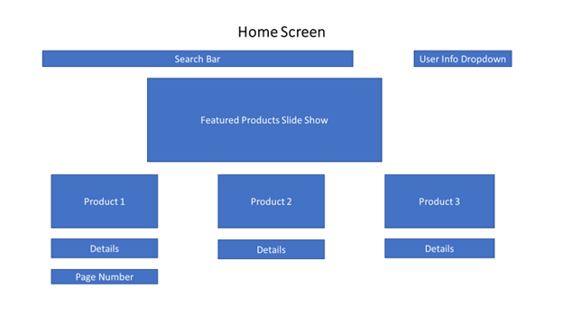

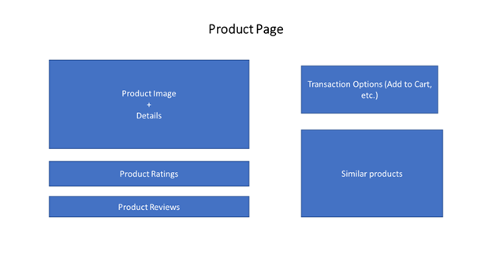

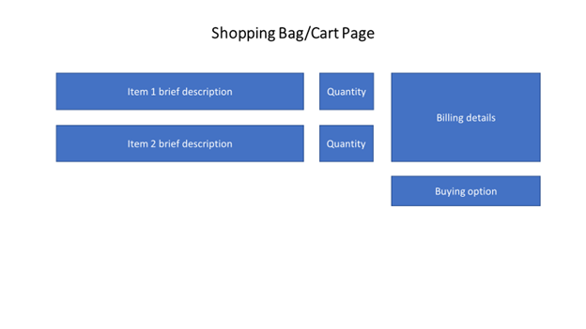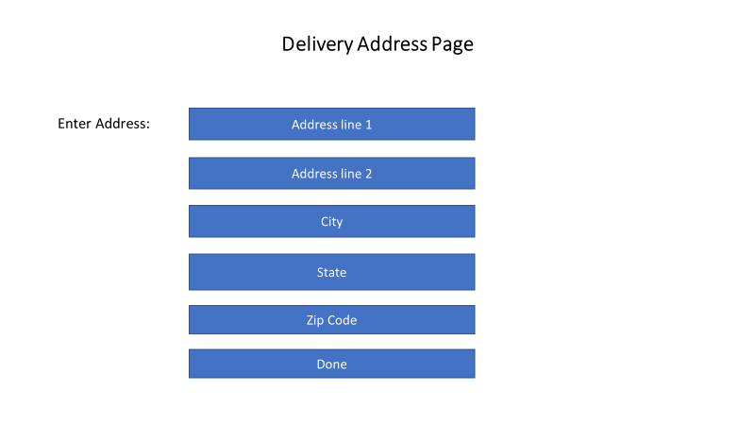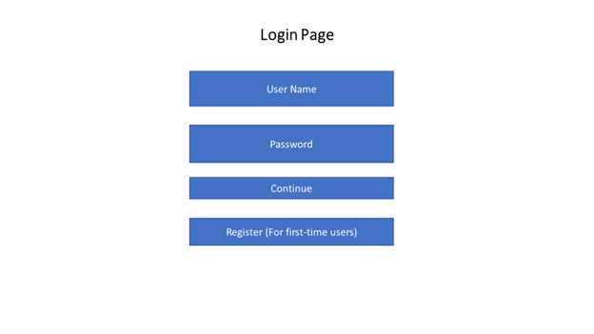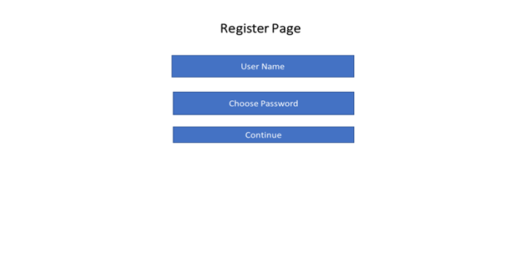

**Project work distribution:** Each member of the group will be working on 1-2 screens as mentioned above. The members will be working on both the front end and the backend parts of their respective screens.